A

Mini Project Report

on

**ONLINE ASSESSMENT MODULE**

Submitted to



**BHILAI INSTITUTE OF TECHNOLOGY, DURG**

An Autonomous Institute

Affiliated to

**Chhattisgarh Swami Vivekanand Technical University, Bhilai (C.G.)**

***In partial fulfillment of the requirements for the award of***

**Bachelor of Technology**

in

**Computer Science and Engineering, Semester**

Name of the Candidate1 : Gajendra Sahu , University Roll No.:300102221021

Name of the Candidate2 : Gourav Yadav , University Roll No.: 300102221102

Name of the Candidate3 : Kavya Swarnkar , University Roll No.: 300102221050

**Under the Guidance of**

**PROF. DR. SUNITA SONI**   **PROF. MRS. MONIKA VERMA**

**Session 2022-2023**

**DECLARATION BY THE CANDIDATES**

We the undersigned solemnly declare that the report of the project work entitled Online Assessment Module, is based on my own work carried out during the course of our study under the supervision of Dr.(Mrs.)Sunita Soni.

We assert that the statements made and conclusions drawn are an outcome of the project work. We further declare that to the best of our knowledge and belief that the report does not contain any part of any work which has been submitted for the award of any other degree/diploma/certificate in this University/ any other University of India or any other country.

| Signature of the Guide  Mrs. Monika Verma  Assistant Professor  Computer Sc. & Engg. |  |  |
| --- | --- | --- |
| (Signature of the Candidate)  Name: Gajendra Sahu  URNo.: 300102221021  Enrollment No.:CA6458  Sem: 3rd | (Signature of the Candidate)  Name: Gourav Yadav  URN: 300102221  Enrollment No.:CB295  Sem:3rd | (Signature of the Candidate)  Name: Kavya Swarnkar  URN: 300102221050  Enrollment No.: CA6446  Sem:3rd |

**CERTIFICATE**

This is to certify that the report of the project submitted is an outcome of the project work entitled Online Assessment Module is carried out under my guidance and supervision for the award of Degree in Bachelor of Engineering in Computer Science from Chhattisgarh Swami Vivekanand Technical University, Bhilai (C.G).

To the best of my knowledge the report

i) Embodies the work of the candidate himself / herself,

ii) Has duly been completed,

iii) Fulfills the requirement of the Ordinance relating to the BE degree of the University,

iv) Is up to the desired standard for the purpose of which is submitted.

Signature of Coordinator

Mrs. Monika Verma

Computer Sc. & Engg.

The Project work as mentioned above is hereby being recommended and forwarded for examination and evaluation.

Dr. (Mrs.) Sunita Soni

Head of the Department

Computer Sc. & Engg

**CERTIFICATE BY THE EXAMINERS**

This is to Certify that the project the entitled

“ONLINE ASSESSMENT MODULE”,

Submitted by

| Name: Gajendra Sahu | Enrollment No.: :CA6458 | Roll No.: 300102221021 |
| --- | --- | --- |
| Name: Gourav Yadav | Enrollment No.: CB4295 | Roll No.: 300102221102 |
| Name: Kavya Swarnkar | Enrollment No.: :CA6446 | Roll No.: 300102221050 |

Have been examined by the undersigned as a part of the examination for the award of Bachelor of Engineering degree in Computer Science and Engineering from Chhattisgarh Swami Vivekanand Technical University, Bhilai (C.G)

|  |  |
| --- | --- |
| Internal examiner | External examiner |
| Date: | Date: |

**ACKNOWLEDGEMENT**

We have great pleasure in the submission of this project report entitled ONLINE ASSESSMENT MODULE in partial fulfillment the degree of Bachelor of Engineering (CSE). While submitting this Project report, we take this opportunity to thank those directly or indirectly related to project work.

We would like to express sincere thanks and gratitude to Dr. Mohan Kumar Gupta, Principal of the Institution, Dr. (Mrs.) Sunita Soni, Head of the Department Computer Science & Engineering for their encouragement and cordial support.

While Submission of the project, we would also like to thank Prof. Mrs Monika Verma , Project Coordinator, faculty and all the staff of department of Computer Science & Engineering, Bhilai Institute of Technology, Durg for their continuous help and guidance throughout the course of project.

Also we would extend our gratitude to our parents, family members, friends and all others who have helped us directly or indirectly in the successful completion of the project work.

| Name:Gajendra Sahu | Enrollment No.: :CA6458 | Roll No.: 300102221021 |
| --- | --- | --- |
| Name:Gourav Yadav | Enrollment No.: CB4295 | Roll No.: 300102221102 |
| Name:Kavya Swarnkar | Enrollment No.: :CA6446 | Roll No.: 300102221050 |

**ABSTRACT**

The internet revolution brought a lot of opportunities in the education sector and the pandemic taught us the modern need of technology for e-learning purposes. The manual method of conducting quizzes, marking every individuals copy and storing their report consumes a lot of time of the faculties and makes a hectic work load on them.

The report consists of the working and result of the Online Assessment Software also it consists of the future scope and implementation that can be done to improvise the project and increase the level of the project to be used at universities . The main objective of Online Software Assessment is to minimize the work load and the issues regarding the manual method of conducting quizzes.

**CONTENTS**

| **TOPICS** | **PG.NO** |
| --- | --- |
| **1.INTRODUCTION**  **1.1 PROJECT DESCRPITION**  **1.2 WORKING CONCEPT** | **01-02** |
| **2. SOFTWARE REQUIREMENTS** | **03** |
| **3. SCHEMA**   * **3.1 SCHEMA FOR STUDENT'S REGISTRATION** * **3.2 SCHEMA FOR TEACHER'S REGISTRATION** * **3.3 SCHEMA FOR QUESTION ADDITION** | **03-05** |
| **4. RESULT**   * 1. **HOME PAGE**   **4.2 STUDENT'S LOGIN AND REGISTER PAGE**  **4.3 STUDENT'S INTERFACE**  **4.4 STUDENT'S RESGISTERATION**  **4.5 TEST FOR STUDENT**  **4.6 REPORT OF STUDENT**  **4.7 TEACHER'S LOGIN AND REGISTER PAGE**  **4.8 TEACHER 'S INTERFACE**  **4.9 TEACHER'S RESGISTERATION**  **4.10 TEST CREATION FOR TEACHER**  **4.11 STUDENTS RECORD** | **05-09** |
| **5. CONCLUSION** | **09** |
| **6. SCOPE AND FUTURE APPLICATION**  **6.1 SCOPE**  **6.2 FUTURE APPLICATION AND IMPLEMENTATION** | **09-10** |
| **7.ADVANATAGES** | **10** |
| **8.BILIOGRAPHY** | **11** |

**1. INTRODUCTION**

Nowadays, a lot of universities in our country and each of the university consist of student up to two thousand. In order to handle a large amount of student may cause a lot of problem especially in management in the quiz manually.

The use of online quiz systems has become quite popular in the recent years due to pressures of increasing class sizes and the need for more efficient and effective methods of assessing distant students. It is due to the popularity of distant education. Still now maximum educational institutes have been using manual system to take quiz.

The aim of this project is to computerized the existing manual system and help the examiners to save their valuable time and important data, checking the answer sheets after taking test, waste the examiners time, so this application will check the correct answer and save the examiner time. Apart from this, data which are exist in this system, will exist for long period of time and will be easy accessible. This project helps the examiners to manage their services in a good way and provide a better service to both faculty and students.

The objective of this project is to manage the details of students, examinations, marks, courses and papers in a good manner. The performance of the application will be fully control by administrator and administrator can guaranty any one to access. The project will reduce the manual process in managing examinations and all issues regarding that.

**1.1 PROJECT DESCRPITION**

The ‘Online Assessment Software’ project will be developed to overcome the time consuming problem of manual system. Functionalities of the project are as follows:

* Examiners will be able to punch the MCQ questions online.
* Able the users to solve the questions online.
* Examiners can manage the information regarding exam.
* Correct answers will be evaluated by system (First it should be determined by examiner).
* Users can see their result after submitting the test.
* All the records of the students will be stored.

**1.2**.  **WORKING CONCEPT**

The concept behind the software if simple we have used these modules and these modules have logical connections to other modules as they are interdependent.

**Teacher Login:** Able the teachers to login to system with a valid email id and password. If a teacher is successfully login to system, he/she will have access to following pages:

* **Teacher Home:** Which have information about Online MCQ Quiz and issues support by this system for the teachers.
* **Create Test:** Which able the teacher to punch a test and will be able to add questions to the particular test.
* **Students Marks:** Which able the teacher to observe the result of all student who have attempted the tests.

**Student Login:** Able the students to login to system with a valid email id an and password. If student is successfully login to system, he/she will have access to following pages:

* **Student Home:** Which have information about Online MCQ Quiz and issues support by this system for students.
* **Attempt Test:** Which able the student to select a particular test for attempting from the existing test and questions of selected test will be displayed for the student to attempt. Then student will be able to attempt the questions and submit it.
* **Marks:** Which able the particular students to have access to result of the test which he/she attempted.

**2. SOFTWARE REQUIREMENTS**

Languages used:

* HTML
* CSS
* JavaScript
* MondoDB
* NodeJS

**3. SCHEMA**

* **3.1 SCHEMA FOR STUDENT'S REGISTRATION**

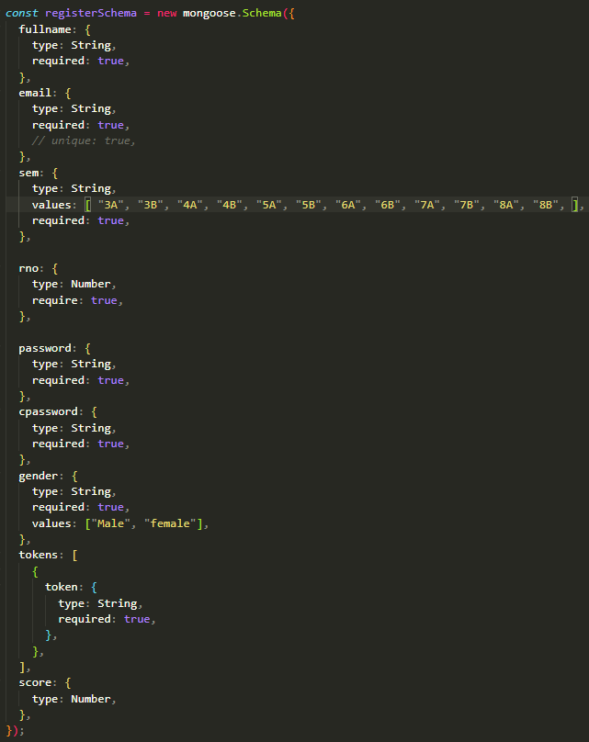

* **3.2 SCHEMA FOR TEACHER'S REGISTRATION**

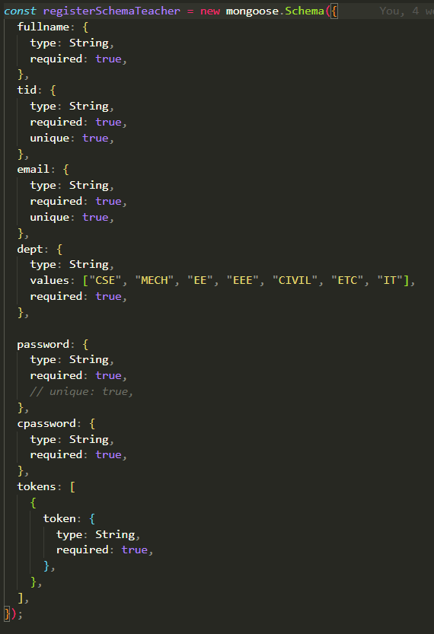

* **3.3 SCHEMA FOR QUESTION ADDITION**

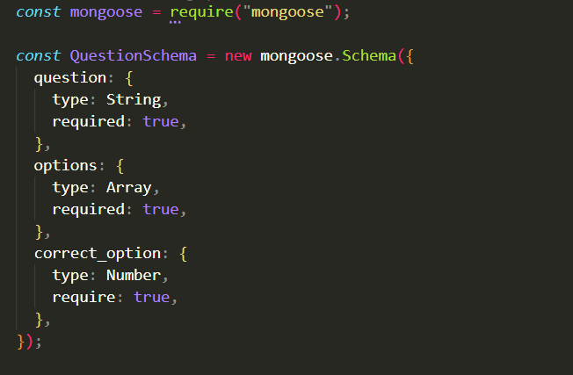

**4. RESULT**

The result of our project is as follow:

* **HOME PAGE**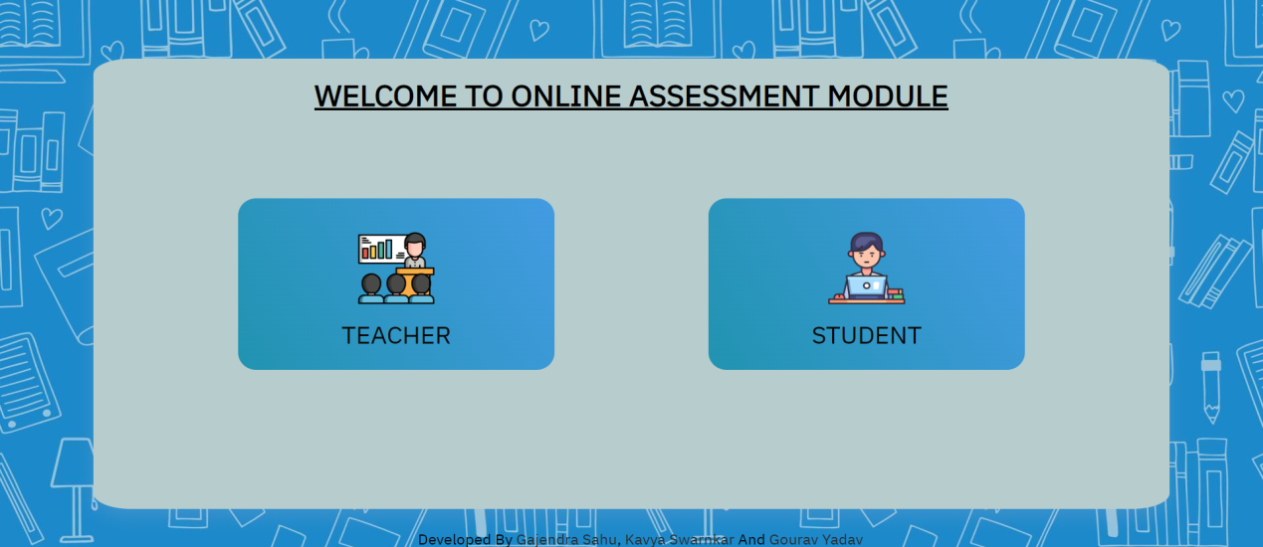
* **STUDENT'S LOGIN AND REGISTER PAGE**

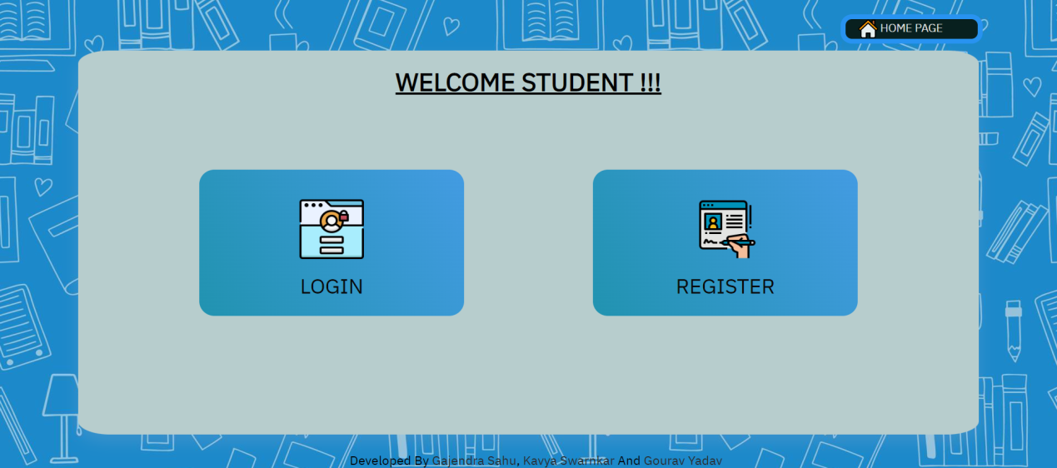

* **STUDENT'S RESGISTERATION**

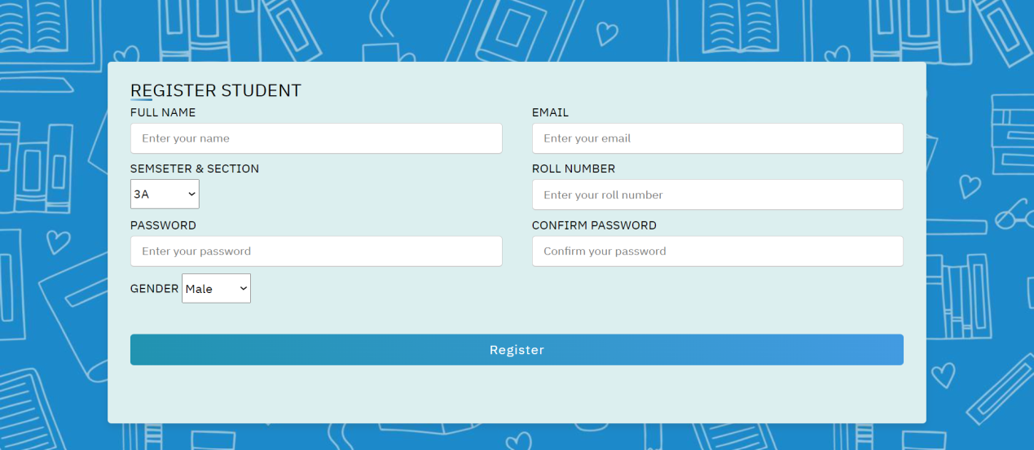

* **STUDENT'S LOGIN**

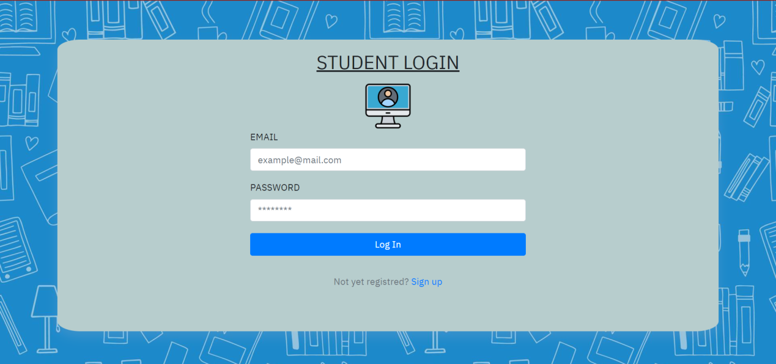

* **STUDENT'S INTERFACE**

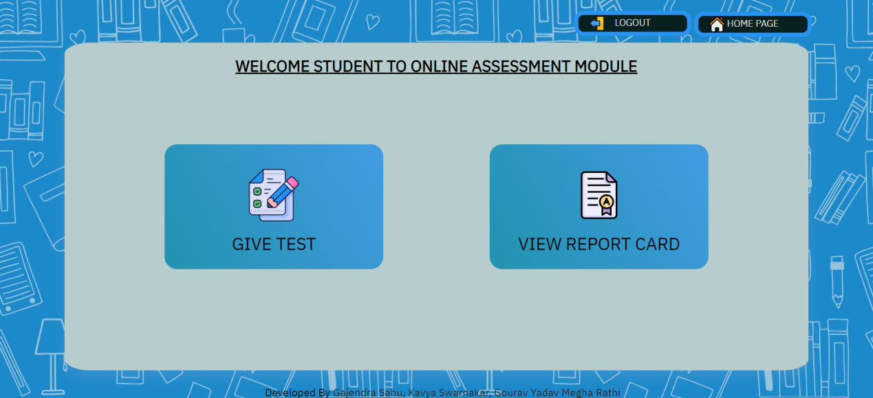

* **TEST FOR STUDENT**

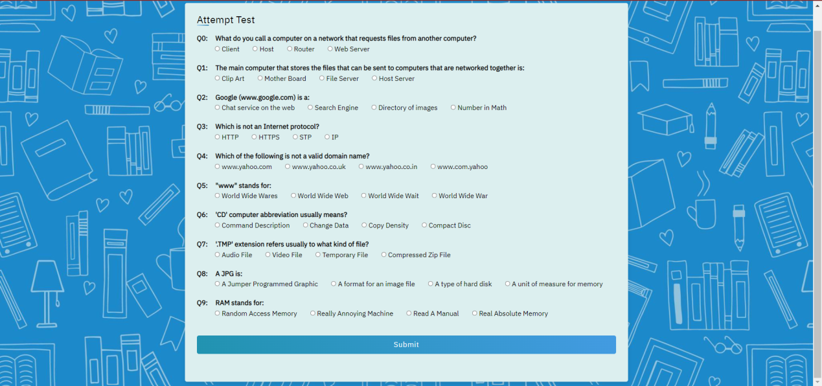

* **REPORT OF STUDENT**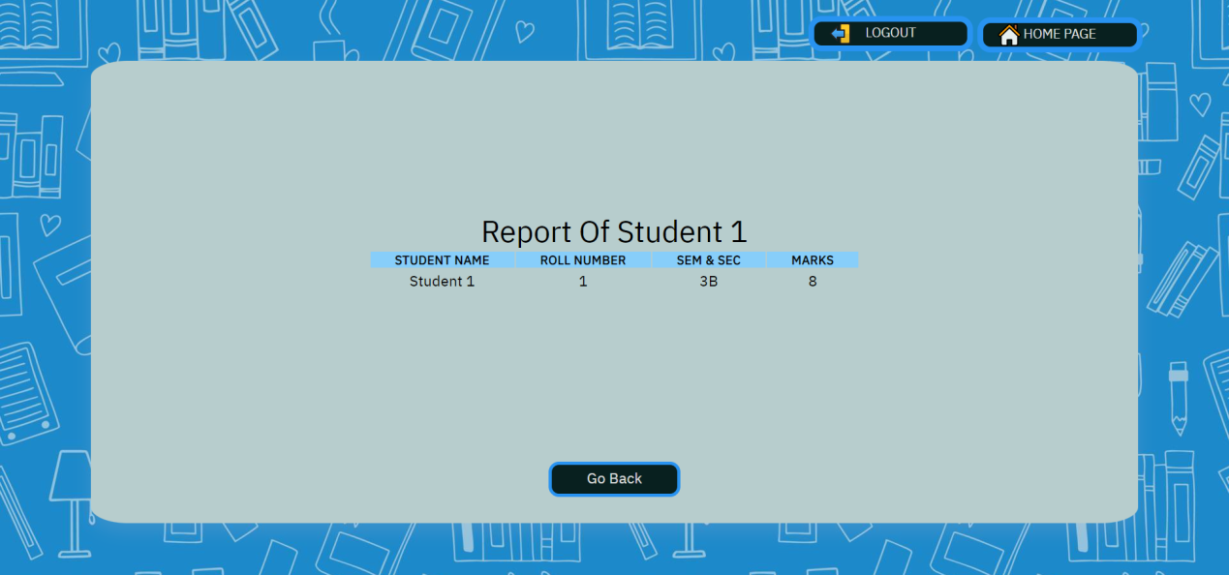
* **TEACHER'S LOGIN AND REGISTER PAGE**

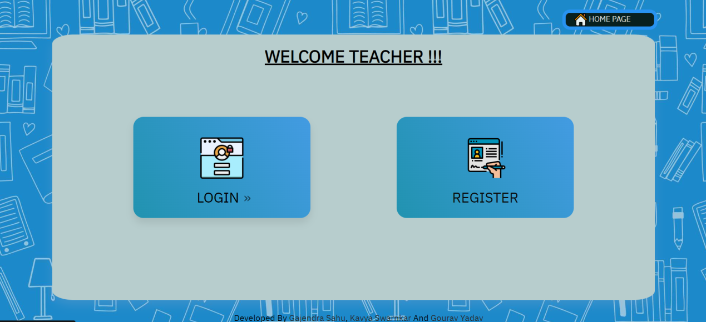

* **TEACHER'S RESGISTERATION**

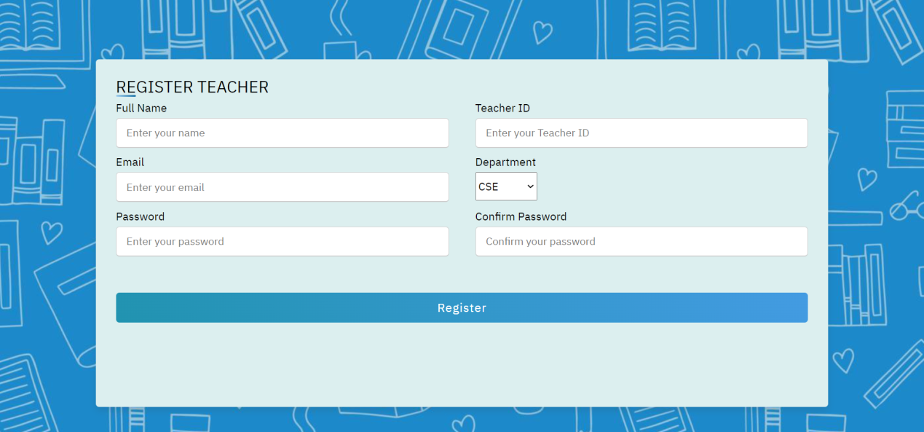

* **TEACHER'S LOGIN**

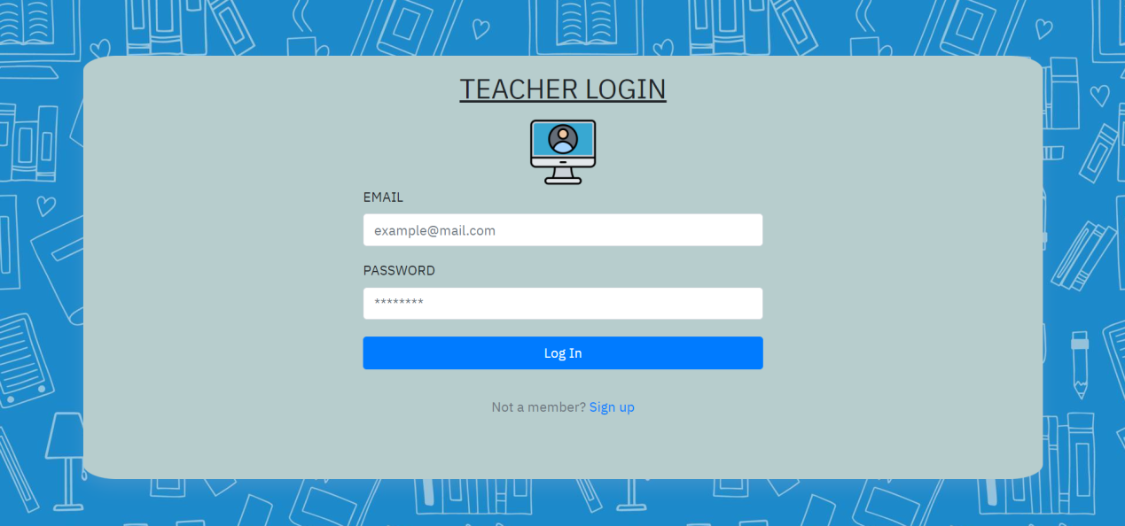

* **TEACHER 'S INTERFACE**

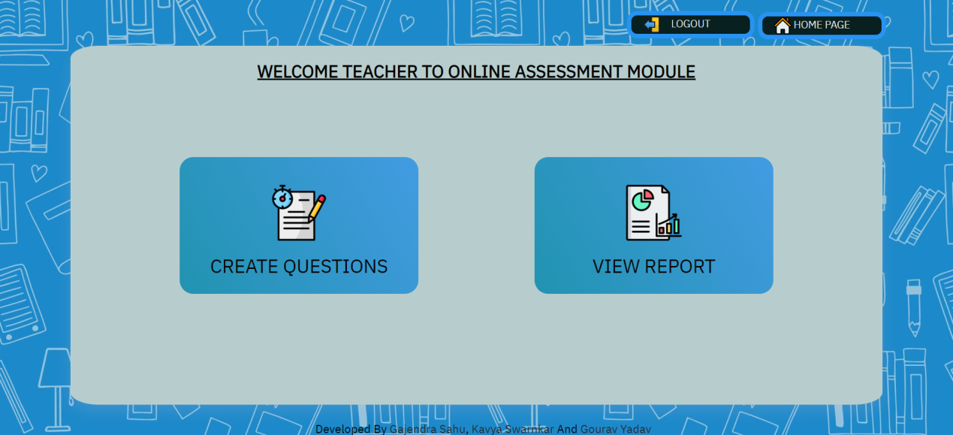

* **ADDITION OF QUESTION FOR TEACHER**

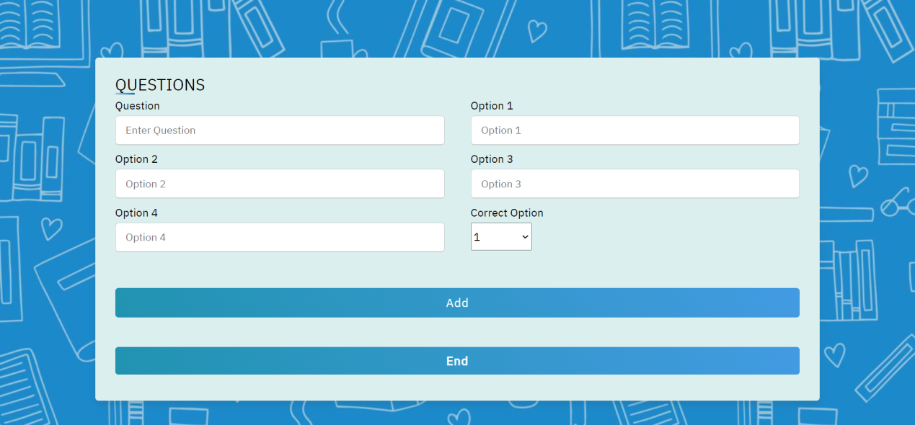

* **STUDENTS RECORD**

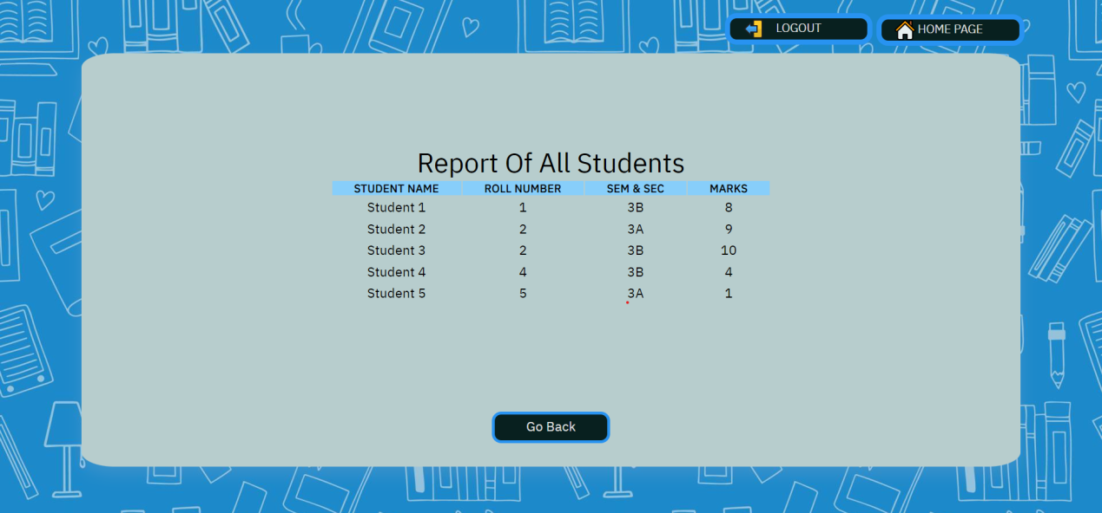

**5. CONCLUSION**

The impact of technology on the education sector is undoubtedly beneficial. First and foremost, teaching and, in consequence, evaluating students are two actions which should not be limited within the walls of a classroom but they can be both performed anytime, anywhere with the aid of computers and the internet.

It’s not surprising that the industries are gradually moving from using the traditional assessment methods to using more practical ones which are almost always towards technological solutions.

Research has also proven that most students are interested in going through an online assessment rather than a paper-and-pencil one. Moreover, the students are delighted when they get their results and feedback automatically immediately after the test.

**6. SCOPE AND FUTURE APPLICATION**

With tremendous changes in the educational sector, the use of online assessment has become more popular and widely adopted and our project being of the same category can serve as one of the good alternative for traditional assessment methods.

**6.1 SCOPE:**

* Conduction of exam effortlessly.
* Promotes social interaction between teachers and students.
* Safe and secured data.
* Reduces administrative burden.
* Based on modern infrastructure

**6.2 FUTURE APPLICATION AND IMPLEMENTATION:**

* Introducing a feature of partial marking for example if in multiple correct question if one answer is marked correct then the student will be getting the marks according to the marking for that particular correct answer instead of complete zero mark.
* Implementing the online assessment feature for our college and then introducing it to other universities.
* We will try to add more features for teachers as well as students.

**7. ADVANTAGES**

* Prompt result after an examination relieves students' anxiety
* Instant feedback supports the formative assessment method
* Conducting an examination anytime, anywhere is beneficial to the students
* Fun and interactive
* Taking exams in a comfortable environment is key
* Beneficial to students who have to prepare for different competitive exams
* Eases out process of online assessment test in institutes.
* Stores requested data of students and question bank of teachers in a order

**8. BIBLIOGRPHY**

[1] “CSS: Cascading Style Sheets” developer.mozilla.org <https://developer.mozilla.org/en-US/docs/Web/CSS>

[2] “Basic concepts of flexbox” developer.mozilla.org <https://developer.mozilla.org/en-US/docs/Web/CSS/CSS_Flexible_Box_Layout/Basic_Concepts_of_Flexbox>

[3] “Using HTTP APIs” devdocs.io <https://devdocs.io/node/http#httpgeturl-options-callback>

[4] “How to connect to mongoDB compass with Node.js” stackoverflow.com <https://stackoverflow.com/questions/51747101/how-to-connect-to-mongodb-compass-with-node-js>

[5] ”Password encryption in Node.js using bcryptjs module” geeksforgeeks.org <https://www.geeksforgeeks.org/password-encryption-in-node-js-using-bcryptjs-module/>

[6] “Using JSON Web Tokens (JWTs)” cloud.google.com <https://cloud.google.com/iot/docs/how-tos/credentials/jwts>